The **Collection in Java** is a framework that provides architecture to store and manipulate the group of objects.

Java Collections can achieve all the operations that you perform on a data such as searching, sorting, insertion, manipulation, and deletion.

Java Collection means a single unit of objects. Java Collection framework provides many interfaces (Set, List, Queue, Deque) and classes (ArrayList, Vector, LinkedList, PriorityQueue, HashSet, LinkedHashSet, TreeSet).

# Collections in Java

1. [Java Collection Framework](https://www.javatpoint.com/collections-in-java)
2. [Hierarchy of Collection Framework](https://www.javatpoint.com/collections-in-java#collectionhierarchy)
3. [Collection interface](https://www.javatpoint.com/collections-in-java#collectionmethods)
4. [Iterator interface](https://www.javatpoint.com/collections-in-java#collectioniterator)

The **Collection in Java** is a framework that provides an architecture to store and manipulate the group of objects.

Java Collections can achieve all the operations that you perform on a data such as searching, sorting, insertion, manipulation, and deletion.

Java Collection means a single unit of objects. Java Collection framework provides many interfaces (Set, List, Queue, Deque) and classes (ArrayList, Vector, LinkedList, PriorityQueue, HashSet, LinkedHashSet, TreeSet).

#### What is a framework in Java

* It provides readymade architecture.
* It represents a set of classes and interfaces.
* It is optional.

#### What is Collection framework

The Collection framework represents a unified architecture for storing and manipulating a group of objects. It has:

1. Interfaces and its implementations, i.e., classes
2. Algorithm

**What Is a Collections Framework?**

A *collections framework* is a unified architecture for representing and manipulating collections. All collections frameworks contain the following:

* **Interfaces:** These are abstract data types that represent collections. Interfaces allow collections to be manipulated independently of the details of their representation. In object-oriented languages, interfaces generally form a hierarchy.
* **Implementations:** These are the concrete implementations of the collection interfaces. In essence, they are reusable data structures.
* **Algorithms:** These are the methods that perform useful computations, such as searching and sorting, on objects that implement collection interfaces. The algorithms are said to be *polymorphic*: that is, the same method can be used on many different implementations of the appropriate collection interface. In essence, algorithms are reusable functionality.

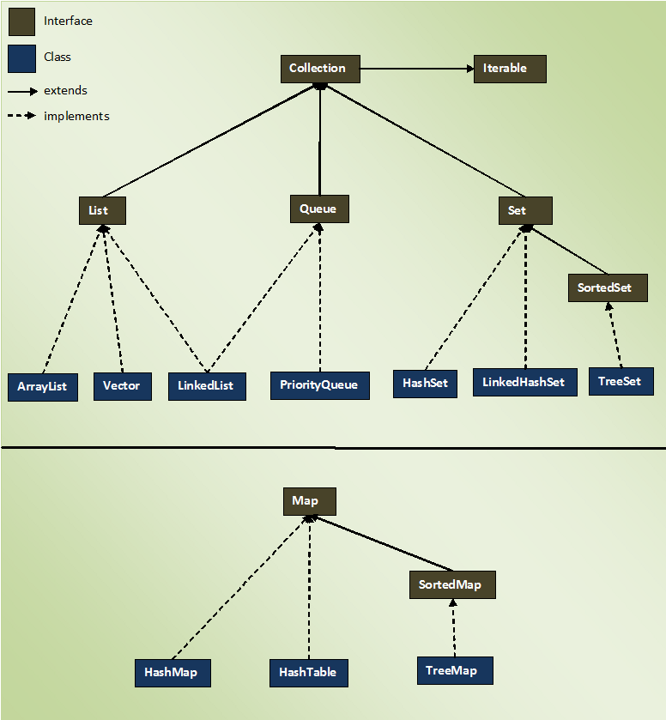

### Iterator interface

|  |
| --- |
| Iterator interface provides the facility of iterating the elements in a forward direction only. |

#### Methods of Iterator interface

There are only three methods in the Iterator interface. They are:

|  |  |  |
| --- | --- | --- |
| No. | Method | Description |
| 1 | public boolean hasNext() | It returns true if the iterator has more elements otherwise it returns false. |
| 2 | public Object next() | It returns the element and moves the cursor pointer to the next element. |
| 3 | public void remove() | It removes the last elements returned by the iterator. It is less used. |

**Collection Interface**

The Collection interface is the interface which is implemented by all the classes in the collection framework. It declares the methods that every collection will have. In other words, we can say that the Collection interface builds the foundation on which the collection framework depends.

Some of the methods of Collection interface are Boolean add ( Object obj), Boolean addAll ( Collection c), void clear(), etc. which are implemented by all the subclasses of Collection interface.

**List Interface**

List interface is the child interface of Collection interface. It inhibits a list type data structure in which we can store the ordered collection of objects. It can have duplicate values.

List interface is implemented by the classes ArrayList, LinkedList, Vector, and Stack.

To instantiate the List interface, we must use :

1. List <data-type> list1= **new** ArrayList();
2. List <data-type> list2 = **new** LinkedList();
3. List <data-type> list3 = **new** Vector();

There are various methods in List interface that can be used to insert, delete, and access the elements from the list.

The classes that implement the List interface are given below.

**ArrayList**

The ArrayList class implements the List interface. It uses a dynamic array to store the duplicate element of different data types. The ArrayList class maintains the insertion order and is non-synchronized. The elements stored in the ArrayList class can be randomly accessed. Consider the following example.

1. **import** java.util.*;
2. **class** TestJavaCollection1{
3. **public** **static** **void** main(String args[]){
4. ArrayList<String> list=**new** ArrayList<String>();//Creating arraylist
5. list.add("abc");//Adding object in arraylist
6. list.add("def");
7. //Traversing list through Iterator
8. Iterator itr=list.iterator();
9. **while**(itr.hasNext()){
10. System.out.println(itr.next());
11. }
12. }
13. }

# CopyOnWriteArrayList in java(Important)

**CopyOnWriteArrayList**: CopyOnWriteArrayList class is introduced in JDK 1.5, which implements List interface. It is enhanced version of ArrayList in which all modifications (add, set, remove, etc) are implemented by making a fresh copy.

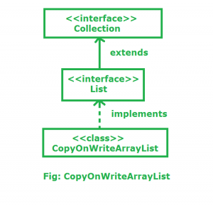

Here are few points about CopyOnWriteArrayList:

* As the name indicates, CopyOnWriteArrayList creates a Cloned copy of underlying ArrayList, for every update operation at certain point both will be synchronized automatically ,which is taken care by JVM. Therefore there is no effect for threads which are performing read operation.
* It is costly to use because for every update operation a cloned copy will be created. Hence CopyOnWriteArrayList is the best choice if our frequent operation is read operation.
* It extends object and implements Serializable, Cloneable, Iterable<E>, Collection<E>, List<E> and RandomAccess
* It is thread-safe version of ArrayList.

**LinkedList**

LinkedList implements the Collection interface. It uses a doubly linked list internally to store the elements. It can store the duplicate elements. It maintains the insertion order and is not synchronized. In LinkedList, the manipulation is fast because no shifting is required.

Consider the following example.

1. **import** java.util.*;
2. **public** **class** TestJavaCollection2{
3. **public** **static** **void** main(String args[]){
4. LinkedList<String> al=**new** LinkedList<String>();
5. al.add("abc");
6. al.add("def");
7. Iterator<String> itr=al.iterator();
8. **while**(itr.hasNext()){
9. System.out.println(itr.next());
10. }
11. }
12. }

**Vector**

Vector uses a dynamic array to store the data elements. It is similar to ArrayList. However, It is synchronized and contains many methods that are not the part of Collection framework.

Consider the following example.

1. **import** java.util.*;
2. **public** **class** TestJavaCollection3{
3. **public** **static** **void** main(String args[]){
4. Vector<String> v=**new** Vector<String>();
5. v.add("abc");
6. v.add("def");
7. Iterator<String> itr=v.iterator();
8. **while**(itr.hasNext()){
9. System.out.println(itr.next());

**Queue Interface**

Queue interface maintains the first-in-first-out order. It can be defined as an ordered list that is used to hold the elements which are about to be processed. There are various classes like PriorityQueue, Deque, and ArrayDeque which implements the Queue interface.

Queue interface can be instantiated as:

1. Queue<String> q1 = **new** PriorityQueue();
2. Queue<String> q2 = **new** ArrayDeque();

There are various classes that implement the Queue interface, some of them are given below.

**PriorityQueue**

The PriorityQueue class implements the Queue interface. It holds the elements or objects which are to be processed by their priorities. PriorityQueue doesn't allow null values to be stored in the queue.

Consider the following example.

1. **import** java.util.*;
2. **public** **class** TestJavaCollection5{
3. **public** **static** **void** main(String args[]){
4. PriorityQueue<String> queue=**new** PriorityQueue<String>();
5. queue.add("Aman");
6. queue.add("Vijay");
7. queue.add("Jai");
8. queue.add("Raj");
9. System.out.println("head:"+queue.element());
10. System.out.println("head:"+queue.peek());
11. System.out.println("iterating the queue elements:");
12. Iterator itr=queue.iterator();
13. **while**(itr.hasNext()){
14. System.out.println(itr.next());
15. }
16. queue.remove();
17. queue.poll();
18. System.out.println("after removing two elements:");
19. Iterator<String> itr2=queue.iterator();
20. **while**(itr2.hasNext()){
21. System.out.println(itr2.next());
22. }
23. }
24. }

**Set Interface**

Set Interface in Java is present in java.util package. It extends the Collection interface. It represents the unordered set of elements which doesn't allow us to store the duplicate items. We can store at most one null value in Set. Set is implemented by HashSet, LinkedHashSet, and TreeSet.

Set can be instantiated as:

1. Set<data-type> s1 = **new** HashSet<data-type>();
2. Set<data-type> s2 = **new** LinkedHashSet<data-type>();
3. Set<data-type> s3 = **new** TreeSet<data-type>();
4. Set<data-type> s3 = **new** TreeSet<data-type>();

**HashSet**

HashSet class implements Set Interface. It represents the collection that uses a hash table for storage. Hashing is used to store the elements in the HashSet. It contains unique items.

Consider the following example.

1. **import** java.util.*;
2. **public** **class** TestJavaCollection7{
3. **public** **static** **void** main(String args[]){
4. //Creating HashSet and adding elements
5. HashSet<String> set=**new** HashSet<String>();
6. set.add("abc");
7. set.add("ab");
8. set.add("abc");
9. set.add("abcd");
10. //Traversing elements
11. Iterator<String> itr=set.iterator();
12. **while**(itr.hasNext()){
13. System.out.println(itr.next());
14. }
15. }
16. }

|  |  |
| --- | --- |
| **Comparable** | **Comparator** |
| **1) Comparable provides a single sorting sequence. In other words, we can sort the collection on the basis of a single element such as id, name, and price.** | **The Comparator provides multiple sorting sequences. In other words, we can sort the collection on the basis of multiple elements such as id, name, and price etc.** |
| **2) Comparable affects the original class, i.e., the actual class is modified.** | **Comparator doesn't affect the original class, i.e., the actual class is not modified.** |
| **3) Comparable provides compareTo() method to sort elements.** | **Comparator provides compare() method to sort elements.** |
| **4) Comparable is present in java.lang package.** | **A Comparator is present in the java.util package.** |
| **5) We can sort the list elements of Comparable type by Collections.sort(List) method.** | **We can sort the list elements of Comparator type by Collections.sort(List, Comparator) method.** |

# Java Map Interface

A map contains values on the basis of key, i.e. key and value pair. Each key and value pair is known as an entry. A Map contains unique keys.

A Map is useful if you have to search, update or delete elements on the basis of a key.

## Java Map Hierarchy

There are two interfaces for implementing Map in java: Map and SortedMap, and three classes: HashMap, LinkedHashMap, and TreeMap. The hierarchy of Java Map is given below:

Java Map Hierarchy

**A Map doesn't allow duplicate keys, but you can have duplicate values. HashMap and** LinkedHashMap allow null keys and values, but TreeMap doesn't allow any null key or value.

A Map can't be traversed, so you need to convert it into Set using keySet() or entrySet() method.

**Why and When to use Maps?**  
Maps are perfect to use for key-value association mapping such as dictionaries. The maps are used to perform lookups by keys or when someone wants to retrieve and update elements by keys. Some examples are:

* A map of zip codes and cities.
* A map of managers and employees. Each manager (key) is associated with a list of employees (value) he manages.
* A map of classes and students. Each class (key) is associated with a list of students (value).

|  |  |
| --- | --- |
| **Class** | **Description** |
| [HashMap](https://www.javatpoint.com/java-hashmap) | HashMap is the implementation of Map, but it doesn't maintain any order. |
| [LinkedHashMap](https://www.javatpoint.com/java-linkedhashmap) | LinkedHashMap is the implementation of Map. It inherits HashMap class. It maintains insertion order. |
| [TreeMap](https://www.javatpoint.com/java-treemap) | TreeMap is the implementation of Map and SortedMap. It maintains ascending order. |

### Useful methods of Map interface

|  |  |
| --- | --- |
| **Method** | **Description** |
| V put(Object key, Object value) | It is used to insert an entry in the map. |
| void putAll(Map map) | It is used to insert the specified map in the map. |
| V remove(Object key) | It is used to delete an entry for the specified key. |
| Set keySet() | It returns the Set view containing all the keys. |
| Set<Map.Entry<K,V>> entrySet() | It returns the Set view containing all the keys and values. |
| void clear() | It is used to reset the map. |
| boolean equals(Object o) | It is used to compare the specified Object with the Map. |
| boolean isEmpty() | This method returns true if the map is empty; returns false if it contains at least one key. |
| V replace(K key, V value) | It replaces the specified value for a specified key. |
| int size() | This method returns the number of entries in the map. |

### Java Map Example: Non-Generic

1. //Non-generic
2. **import** java.util.*;
3. **public** **class** MapExample1 {
4. **public** **static** **void** main(String[] args) {
5. Map map=**new** HashMap();
6. //Adding elements to map
7. map.put(1,"Aman");
8. map.put(5,"Rahul");
9. map.put(2,"Jai");
10. map.put(6,"Aman");
11. //Traversing Map
12. Set set=map.entrySet();//Converting to Set so that we can traverse
13. Iterator itr=set.iterator();
14. **while**(itr.hasNext()){
15. //Converting to Map.Entry so that we can get key and value separately
16. Map.Entry entry=(Map.Entry)itr.next();
17. System.out.println(entry.getKey()+" "+entry.getValue());
18. }
19. }
20. }

### Java Map Example: Generic

1. **import** java.util.*;
2. **class** MapExample2{
3. **public** **static** **void** main(String args[]){
4. Map<Integer,String> map=**new** HashMap<Integer,String>();
5. map.put(100,"Aman");
6. map.put(101,"Vijay");
7. map.put(102,"Rahul");
8. //Elements can traverse in any order
9. **for**(Map.Entry m:map.entrySet()){
10. System.out.println(m.getKey()+" "+m.getValue());
11. }
12. }
13. }

### Java Map Example: comparingByKey() method

1. **import** java.util.*;
2. **class** MapExample3{
3. **public** **static** **void** main(String args[]){
4. Map<Integer,String> map=**new** HashMap<Integer,String>();
5. map.put(100,"Amit");
6. map.put(101,"Vijay");
7. map.put(102,"Rahul");
8. //Returns a Set view of the mappings contained in this map
9. map.entrySet()
10. //Returns a sequential Stream with this collection as its source
11. .stream()
12. //Sorted according to the provided Comparator
13. .sorted(Map.Entry.comparingByKey())
14. //Performs an action for each element of this stream
15. .forEach(System.out::println);
16. }
17. }

### Java Map Example: comparingByKey() in Descending Order

1. **import** java.util.*;
2. **class** MapExample4{
3. **public** **static** **void** main(String args[]){
4. Map<Integer,String> map=**new** HashMap<Integer,String>();
5. map.put(100,"Aman");
6. map.put(101,"Vijay");
7. map.put(102,"Rahul");
8. //Returns a Set view of the mappings contained in this map
9. map.entrySet()
10. //Returns a sequential Stream with this collection as its source
11. .stream()
12. //Sorted according to the provided Comparator
13. .sorted(Map.Entry.comparingByKey(Comparator.reverseOrder()))
14. //Performs an action for each element of this stream
15. .forEach(System.out::println);
16. }
17. }

### Java Map Example: comparingByValue()

1. **import** java.util.*;
2. **class** MapExample5{
3. **public** **static** **void** main(String args[]){
4. Map<Integer,String> map=**new** HashMap<Integer,String>();
5. map.put(100,"Aman");
6. map.put(101,"Vijay");
7. map.put(102,"Rahul");
8. //Returns a Set view of the mappings contained in this map
9. map.entrySet()
10. //Returns a sequential Stream with this collection as its source
11. .stream()
12. //Sorted according to the provided Comparator
13. .sorted(Map.Entry.comparingByValue())
14. //Performs an action for each element of this stream
15. .forEach(System.out::println);
16. }
17. }